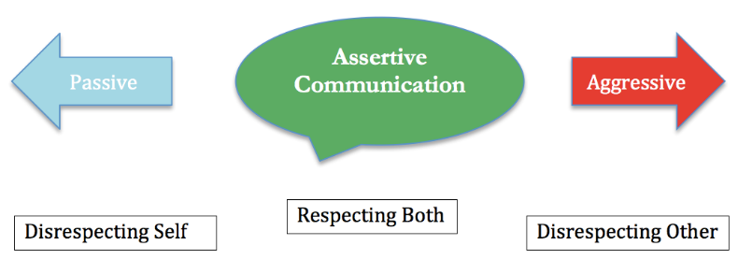
- What does passive mean?

- What does aggressive mean?

- What does assertive mean?

ASSERTIVE COMMUNICATION LOOKS AND SOUNDS LIKE…
Body Language

Facial Expressions

Tone of Voice

Types of Words used

When are some situations when you should speak assertively?

