Listening with Attention Skills
- Without saying anything, how can you show others you are listening?

- What can you say to demonstrate that you are listening?

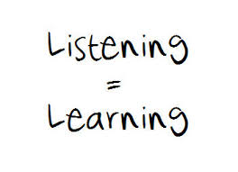
- How can listening improve your school work?

- How can listening help with your friendships?

- Rate yourself on your listening skill. (1=not good, 5=very good)
1 2 3 4 5

- What can you do to improve your listening?

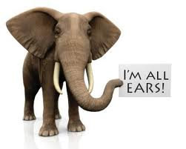
- When/where/with who do you need to improve your listening?

